*Team Members*

Thomas CollinsCharlie Nitschelm  
Lucas Simmonds  
Ross Thyne

Systems Project Proposal

# Build, Code and Test a Quadcopter

Quadcopters are becoming a huge industry for their agility, speed and reliability. An Arduino will be utilized with the help of a controller transmitter and receiver to create a quadcopter capable of flying. We will use the help of YMFC-3D for general build techniques and overall assembly. Many concepts learned in systems so far will go into this project as well as give the whole team a good understanding of how an Arduino can be used to control a flying object. As we know, a quadcopter might not be able to be shown live in class, so we will create a video detailing the project. A camera attachment might be an additional project, if the time needed to accomplish it is available.

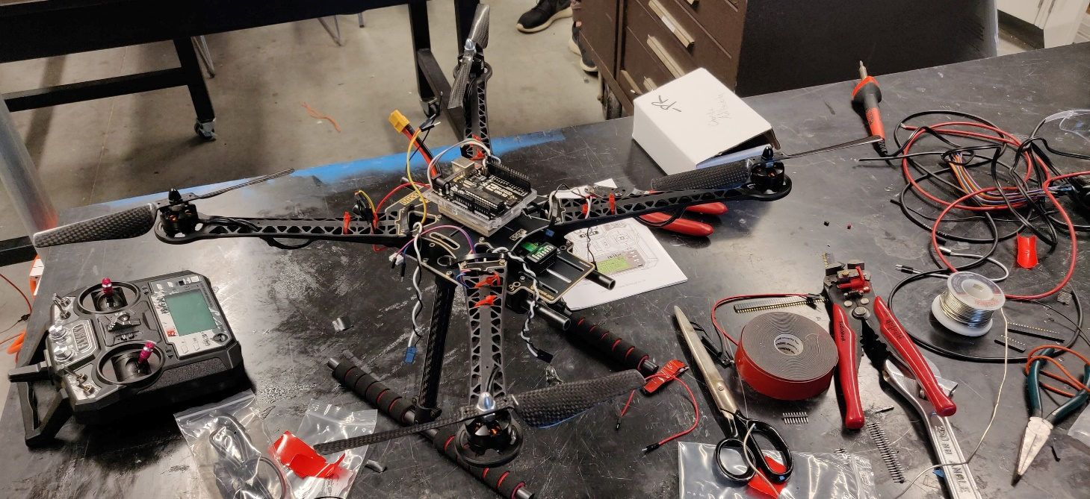

Figure - Current build